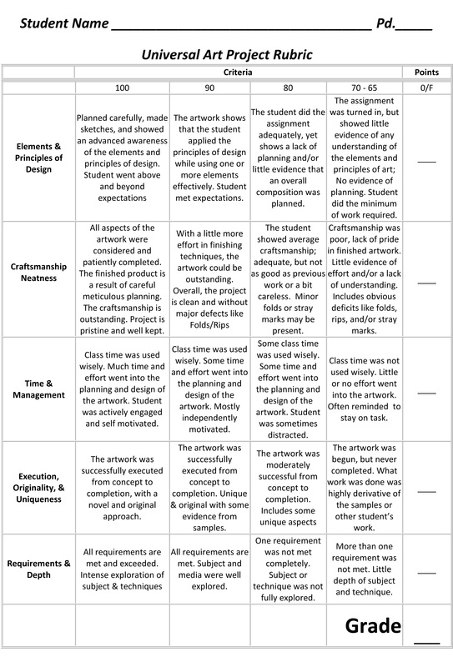
Please describe the most difficult part of this process for you:

What was the simplest/easiest part of this process?

If you were to do this project again, what would you do differently?

